Quiz 1

**Shoaip Eslam AbdELfatah**

**section 4**

In the Hypothetical Machine the contents of memory was as shown. And PC contents is 300. Show the contents of memory and PC , AC , IR after execute three instructions (three fetch cycle and there execute cycle)

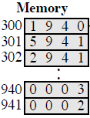

**The Solution**

First Instruction :

-Fetching:

AC : 0000 IR : 1940 PC : 300

940 : 0003 941 : 0002

- Execution :

AC : 0003 IR : 1940 PC : 300

940 : 0003 941 : 0002

Second Instruction :

-Fetching:

AC : 0003 IR : 5940 PC : 301

940 : 0003 941 : 0002

- Execution :

AC : 0005 IR : 2940 PC : 302

940 : 0003 941 : 0002

Third Instruction :

-Fetching:

AC : 0005 IR : 2941 PC : 302

940 : 0003 941 : 0002

- Execution :

AC : 0000 IR : 2941 PC : 302

940 : 0003 941 : 0005

Show the contents of PC , AC and IR and memory after the execution of each instruction of the following program on the Hypothetical Machine:

300 LOAD 550

301 ADD 551

302 STORE 600

Where the contents of memory at 550 is 3 and at 551 is 4.

**The Solution**

First Instruction :

-Fetching:

AC : 0000 IR : 1550 PC : 300

550 : 0003 551 : 0004 600 : 0000

- Execution :

AC : 0003 IR : 1550 PC : 300

550 : 0003 551 : 0004 600 : 0000

Second Instruction :

-Fetching:

AC : 0003 IR : 5551 PC : 301

550 : 0003 551 : 0004 600 : 0000

- Execution :

AC : 0007 IR : 2600 PC : 302

550 : 0003 551 : 0004 600 : 0007

Third Instruction :

-Fetching:

AC : 0007 IR : 2600 PC : 302

550 : 0003 551 : 0004 600 : 0000

- Execution :

AC : 0000 IR : 2600 PC : 302

550 : 0003 551 : 0004 600 : 0007

The following figure provide the main characteristics of Hypothetical Machine.

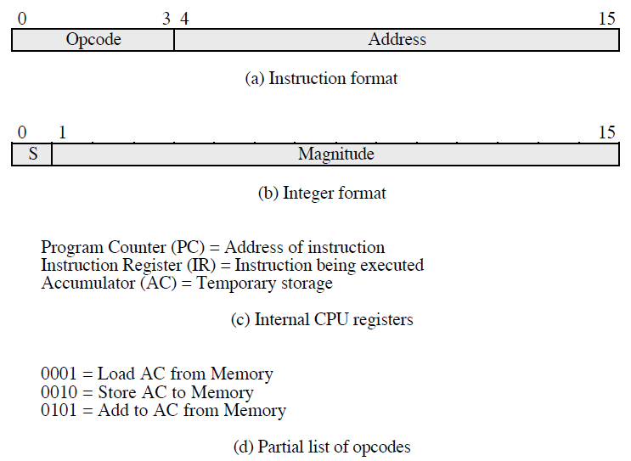

The hypothetical machine also has two I/O instructions:

0011 = load AC from I/O

0111 =store AC to I/O

In these case, the 12-bi address identifies a particular I/O device. Show the program execution for the following program:

1. Load AC from device 5.

2. Add contents of memory location 940.

3. Store AC to device 6.

Assume that the next value retrieved from device 5 is 3 and that location 940 contains a value of 2.

**The Solution**

**Memory**

**300 3005**

**301 5940**

**302 7006**

**After executing the 3 instructions :**

**Device 5 : 0003**

**940 : 2**

**Device 6 : 0005**